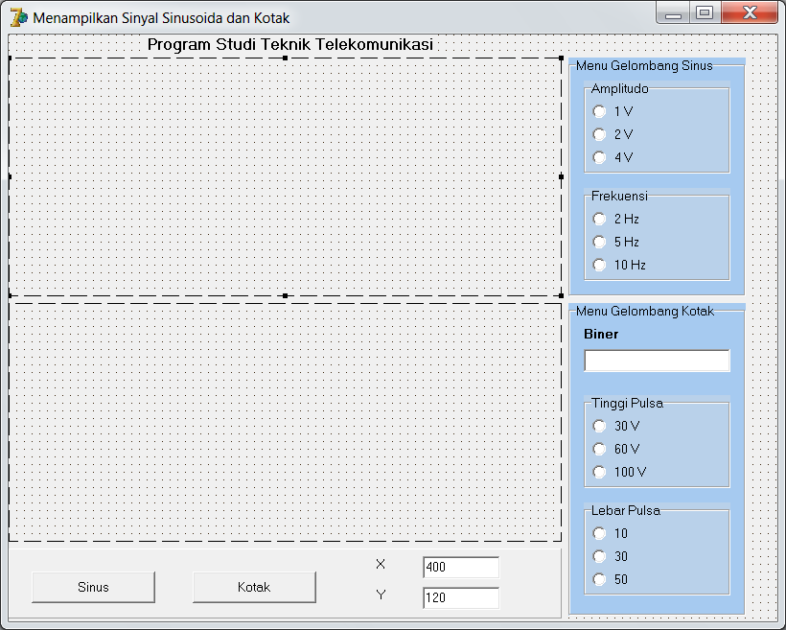

Radio Button

Edit

Panel

Button

Image

Group box

**Properties:**

|  |  |  |
| --- | --- | --- |
| Komponen | *Property* | *Setting* |
| Form | *Caption* | Menampilkan sinyak sinusoida dan kotak |
| *Name* | Frmsinyal |
| Label1 | *Caption* | X |
| Label2 | *Caption* | Y |
| Edit1 | *Text* | 400 |
| *Name* | Edit1 |
| Edit2 | *Text* | 120 |
| *Name* | Edit2 |
| Button1 | *Caption* | Sinus |
| *Name* | Btsinus |
| Edit3 | *Text* | Kosongkan |
| *Name* | Edbiner |
| Button2 | *Caption* | Kotak |
| *Name* | Btkotak |
| Image1 | *Name* | Imgsinus |
| Image2 | *Name* | Imgkotak |
| Panel1 | *Name* | (kosongkan) |
| Groupbox1 | *Name* | Groupbox 1 |
|  | *Caption* | Menu Gelombang Sinus |
| Groupbox2 | *Name* | Amp |
|  | *Caption* | Amplitudo |
| Radio button1 | *Name* | rba1 |
|  | *Caption* | 1V |
| Radio button2 | *Name* | rba2 |
|  | *Caption* | 2V |
| Radio button3 | *Name* | rba4 |
|  | *Caption* | 4V |
| Groupbox3 | *Name* | Frek |
|  | *Caption* | Frekuensi |
| Radio button4 | *Name* | rbf2 |
|  | *Caption* | 2Hz |
| Radio button5 | *Name* | rbf5 |
|  | *Caption* | 5Hz |
| Radio button6 | *Name* | rbf10 |
|  | *Caption* | 10Hz |
| Groupbox4 | *Name* | Groupbox4 |
|  | *Caption* | Menu Gelombang Kotak |
| Groupbox5 | *Name* | Lebar |
|  | *Caption* | Lebar Pulsa |
| Radio button7 | *Name* | rbl10 |
|  | *Caption* | 20 |
| Radio button8 | *Name* | rbl30 |
|  | *Caption* | 60 |
| Radio button9 | *Name* | rbl50 |
|  | *Caption* | 100 |
| Groupbox6 | *Name* | Tinggi |
|  | *Caption* | Tinggi Pulsa |
| Radio button10 | *Name* | rbt10 |
| *Caption* | 10 |
| Radio button11 | *Name* | rbt30 |
| *Caption* | 30 |
| Radio button12 | *Name* | rbt50 |
| *Caption* | 50 |

**Source code:**

*procedure sumbu1(ax,ay,b,c:integer);*

*begin*

*frmsinyal.imgsinus.Canvas.MoveTo(ax,ay);*

*frmsinyal.imgsinus.Canvas.LineTo(ax+b,ay);*

*frmsinyal.imgsinus.Canvas.MoveTo(ax,ay);*

*frmsinyal.imgsinus.Canvas.LineTo(ax,ay-c);*

*frmsinyal.imgsinus.Canvas.MoveTo(ax,ay);*

*frmsinyal.imgsinus.Canvas.LineTo(ax,ay+c);*

*frmsinyal.imgsinus.Canvas.Pen.Color:=clblue;*

*frmsinyal.imgsinus.Canvas.MoveTo(ax,ay+110);*

*frmsinyal.imgsinus.Canvas.LineTo(ax+160,ay+110);*

*frmsinyal.imgsinus.Canvas.MoveTo(ax+220,ay+110);*

*frmsinyal.imgsinus.Canvas.LineTo(ax+390,ay+110);*

*frmsinyal.imgsinus.Canvas.TextOut(ax+170,ay+105,'1 detik');*

*frmsinyal.imgsinus.Canvas.TextOut(ax,ay-c,'Amplitude (A)');*

*frmsinyal.imgsinus.Canvas.TextOut(ax+b-15,ay-15,'Time(t)');*

*frmsinyal.imgsinus.Canvas.TextOut(ax-10,ay-55,'2-');*

*frmsinyal.imgsinus.Canvas.TextOut(ax-10,ay-107,'4-');*

*end;*

*procedure sumbu2(ax,ay,b,c:integer);*

*begin*

*frmsinyal.imgkotak.Canvas.MoveTo(ax,ay);*

*frmsinyal.imgkotak.Canvas.LineTo(ax+b,ay);*

*frmsinyal.imgkotak.Canvas.MoveTo(ax,ay);*

*frmsinyal.imgkotak.Canvas.LineTo(ax,ay-c);*

*frmsinyal.imgkotak.Canvas.MoveTo(ax,ay);*

*frmsinyal.imgkotak.Canvas.LineTo(ax,ay+c);*

*frmsinyal.imgkotak.Canvas.TextOut(ax,ay-c,'Amplitude (v)');*

*frmsinyal.imgkotak.Canvas.TextOut(ax+b-5,ay+5,'Time(s)');*

*frmsinyal.imgkotak.Canvas.TextOut(ax-15,ay-37,'30-');*

*frmsinyal.imgkotak.Canvas.TextOut(ax-15,ay-67,'60-');*

*frmsinyal.imgkotak.Canvas.TextOut(ax-21,ay-107,'100-');*

*end;*

*procedure satu(ax,ay,a,b,i:integer);*

*begin*

*frmsinyal.imgkotak.Canvas.Pen.Color:=clred;*

*frmsinyal.imgkotak.Canvas.MoveTo(ax+(i-1)*b,ay-a);*

*frmsinyal.imgkotak.Canvas.LineTo(ax+b+(i-1)*b,ay-a);*

*end;*

*procedure nol(ax,ay,a,b,i:integer);*

*begin*

*frmsinyal.imgkotak.Canvas.Pen.Color:=clred;*

*frmsinyal.imgkotak.Canvas.MoveTo(ax+(i-1)*b,ay);*

*frmsinyal.imgkotak.Canvas.LineTo(ax+b+(i-1)*b,ay);*

*end;*

*procedure tegak(ax,ay,a,b,i:integer);*

*begin*

*frmsinyal.imgkotak.Canvas.Pen.Color:=clred;*

*frmsinyal.imgkotak.Canvas.MoveTo(ax+(i-1)*b,ay);*

*frmsinyal.imgkotak.Canvas.LineTo(ax+(i-1)*b,ay);*

*end;*

*procedure reset;*

*var*

*x,y:integer;*

*begin*

*frmsinyal.imgsinus.Picture:=nil;*

*frmsinyal.imgsinus.Refresh ;*

*frmsinyal.imgkotak.Picture:=nil;*

*frmsinyal.imgkotak.Refresh ;*

*x:=strtoint(frmsinyal.edsumbux.Text);*

*y:=strtoint(frmsinyal.edsumbuy.Text);*

*sumbu1(20,120,x,y);*

*sumbu2(20,120,x,y);*

*end;*

*procedure Tfrmsinyal.btsinusClick(Sender: TObject);*

*var*

*amp,sx,x,y:integer;*

*sy,frek:real;*

*begin*

*reset;*

*if rba1.Checked then amp:=25; //amplitudo=1 v*

*if rba2.Checked then amp:=50; //amplitudo=2 v*

*if rba4.Checked then amp:=100; //amplitudo=1 v*

*if rbf2.Checked then frek:=10; //amplitudo=4 v*

*if rbf5.Checked then frek:=4; //amplitudo=5 v*

*if rbf10.Checked then frek:=2; //amplitudo=10 v*

*x:=strtoint(frmsinyal.edsumbux.Text);*

*y:=strtoint(frmsinyal.edsumbuy.Text);*

*sumbu1(20,120,x,y);*

*for sx:=1 to 395 do*

*begin*

*sy:=sin(sx/pi/frek)*amp;*

*frmsinyal.imgsinus.Canvas.pixels[sx+20,120-round(sy)]:=clred;*

*end;*

*end;*

*procedure Tfrmsinyal.btkotakClick(Sender: TObject);*

*var*

*i,x,y,tinggi,lebar:integer;*

*biner:string;*

*tnd : integer;*

*begin*

*reset;*

*if rbl10.checked then lebar:=30;*

*if rbl30.checked then lebar:=60;*

*if rbl50.checked then lebar:=100;*

*if rbt10.checked then tinggi:=10;*

*if rbt30.checked then tinggi:=30;*

*if rbt50.checked then tinggi:=50;*

*biner:=edbiner.Text;*

*x:=strtoint(frmsinyal.edit1.Text);*

*y:=strtoint(frmsinyal.edit2.Text);*

*sumbu2(20,120,x,y);*

*tnd:=0;*

*for i:=1 to 16 do*

*if biner[i]='1' then*

*if tnd=0 then begin tegak(20,120,lebar,tinggi,i);*

*satu (20,120,lebar,tinggi,i);*

*tnd:=1; end*

*else satu(20,120,lebar,tinggi,i)*

*else if tnd=1 then begin tegak(20,120,lebar,tinggi,i);*

*nol (20,120,lebar,tinggi,i);*

*tnd:=0; end*

*else nol(20,120,lebar,tinggi,i);*

*end;*

*end.*